**IFT 466 Advanced Computer Networks**

**Lab 15  
BGP – Basic Configuration**

**Objective**BGP is the standard exterior gateway protocol designed to exchange routing and reachability information among autonomous systems on the Internet. BGP connects 2 autonomous systems. BGP is the most widely used exterior protocol.

1. Setup up the following topology on Packet Tracer

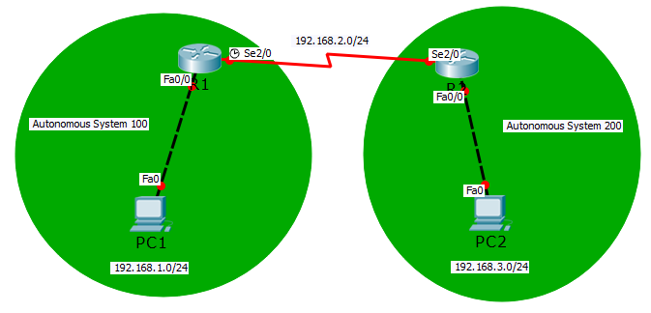

1. Now configure the PCs with IP details.

✓

1. Now let configure R1 with IP settings on both interfaces.

✓

1. Now all the connections should be green

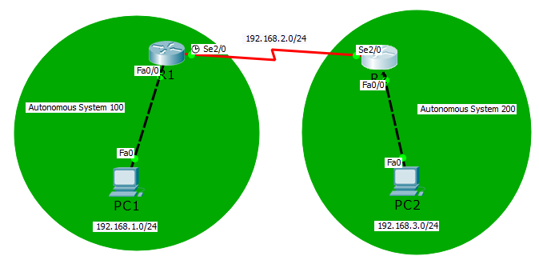



✓

1. Can your ping PC2 from PC1?  
     
   I hope not as we have not yet configured the routing protocol,



✓

1. We will now configure R1 the BGP protocol

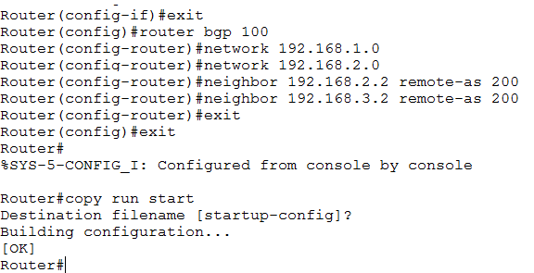  
  
router bgp 100: tells the router that we are referring to AS 100

Then the networks that R1 is joined to…

Then provide the IP addresses of neighboring autonomous system i.e. ip of R1 & PC1



✓

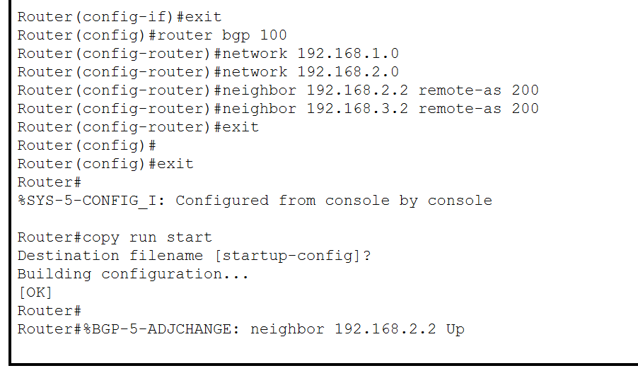

1. We will now configure R2

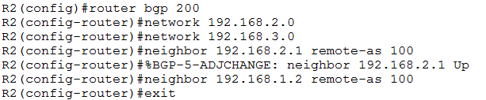



✓

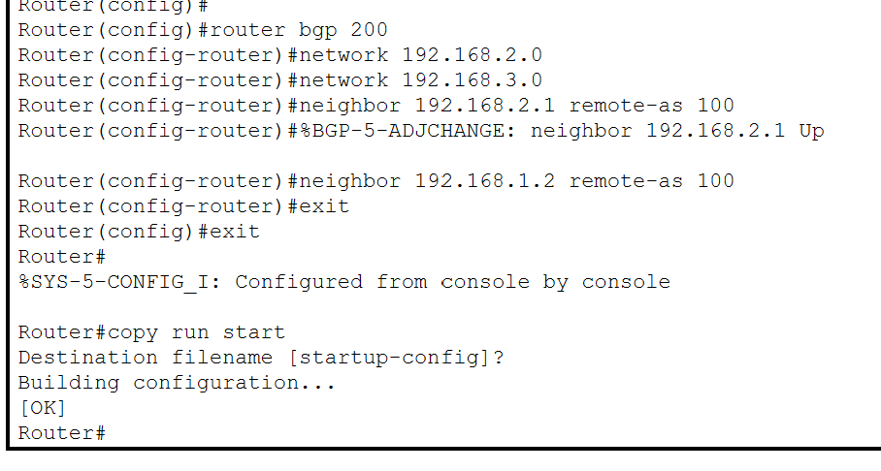

1. Now you should be able to ping PC2 from PC1







